**Sprint 3 Plans**

**Team Number 111**

|  |  |
| --- | --- |
| Student Number | Team Member Name |
| n9458816 | Alexandria Griffiths |
| n9588868 | Akash Mehta |
| n9378171 | Ronald Leung |
| n8599751 | Lorenz Esparcia |
| n9437681 | Alexander Stevens |

Tutor: Prakash Bhandari

Version: 1.1

Date: 12/10/2016

[Sprint Plan](https://docs.google.com/document/d/1LtI_fbHOUZh5js-fV-oaXcgwt21DQaIjtHkykHCLf7w/edit#heading=h.2s8eyo1)

[Sprint 3](https://docs.google.com/document/d/1LtI_fbHOUZh5js-fV-oaXcgwt21DQaIjtHkykHCLf7w/edit#heading=h.17dp8vu)

[Current Velocity:](https://docs.google.com/document/d/1LtI_fbHOUZh5js-fV-oaXcgwt21DQaIjtHkykHCLf7w/edit#heading=h.3rdcrjn)

[Story ID:](https://docs.google.com/document/d/1LtI_fbHOUZh5js-fV-oaXcgwt21DQaIjtHkykHCLf7w/edit#heading=h.26in1rg) #5 Access - Permit Validity

[Story ID:](https://docs.google.com/document/d/1LtI_fbHOUZh5js-fV-oaXcgwt21DQaIjtHkykHCLf7w/edit#heading=h.26in1rg) #27 Regular edits to H&S Issues

Story ID: #7 Access – Varied Payment Options

Story ID: #8 Detailed Payment System

[Sprint Plan Update 12/10/2016](https://docs.google.com/document/d/1LtI_fbHOUZh5js-fV-oaXcgwt21DQaIjtHkykHCLf7w/edit#heading=h.17dp8vu)

**Sprint 3: Link Back-end to Front-end and Payment System**

Total Story Points: 20

Total Hours:   8.5

**Current Velocity:** 20Story Points per Sprint / 14 Hours per Sprint

## Story ID: #5 Access - Permit Validity

|  |  |  |  |
| --- | --- | --- | --- |
| **Task ID** | **Task Description** | **Estimate** | **Taken** |
| **1** | Give permission to vehicle owners to access permit information | 0.5 | 1 |
| **2** | Arrange database to update validity status of every permit | 2 | 3 |
|  | Story Points: 4 Total Hours: | 2.5 | 4 |

## Story ID: #27 Regular edits to H&S Issues

|  |  |  |  |
| --- | --- | --- | --- |
| **Task ID** | **Task Description** | **Estimate** | **Taken** |
| **3** | Give permission to Departments members to access unresolved issues | 1 | 1 |
| **4** | Arrange an editable text section for the issues database | 2 | 5 |
|  | Story Points: 4 Total Hours: | 2 | 6 |

**Story ID: #7 Access – Varied Payment Options**

|  |  |  |  |
| --- | --- | --- | --- |
| **Task ID** | **Task Description** | **Estimate** | **Taken** |
| **5** | Give access to vehicle owners to personal violations, payment page | 1.5 | 2 |
| **6** | Integrate instant payment options | 0.5 | 0.5 |
|  | Story Points: 8 Total Hours: | 2 | 2.5 |

**Story ID: #8 Detailed Payment System**

|  |  |  |  |
| --- | --- | --- | --- |
| **Task ID** | **Task Description** | **Estimate** | **Taken** |
| **7** | Arrange database to provide overview of violations | 0.5 | 0.5 |
| **8** | Payment tracking | 2 | 1 |
|  | Story Points: 4 Total Hours: | 2.5 | 1.5 |

**Sprint Plan Update 12/10/2016**

* Stories adjusted accordingly
* Story #14 ‘Up-to-date Connection’ was added to the documentation of Sprint 2, as the story was then unintentionally completed when databases went live.
* Story #29 ‘Upon Resolution, Enter Additional Info’ is intended to be a later task of adding a ‘SQL NOT NULL Constraint’ and is documented into Sprint 4 instead.
* Initial Remaining Story Points of 20 Story Points and 8.5 hours
* There was a remaining 0 Story Points and required an extra 5.5 hours to complete (this however did not affect the Sprint Story Points Velocity as all Stories were completed)
* The progress of the sprint can be found in the Burndown Chart provided (Figure 1)
* Table 1 is a table for reference for Sprint 3’s Progress

|  |  |  |  |  |  |  |  |
| --- | --- | --- | --- | --- | --- | --- | --- |
| **Day** | **Hours Remaining** | **Date** | **Ideal Story Points Remaining** | **Actual Story Points Remaining** | **Task Worked** | **Task ID** | **Hours Taken to Complete** |
| 28 | 8.50 | 28/09/2016 | 20.00 | 20.00 |  |  |  |
| 29 | 8.50 | 29/09/2016 | 18.57 | 20.00 |  |  |  |
| 30 | 3.50 | 30/09/2016 | 17.14 | 16.00 | Access - Permit Validity, Access for Dept. Members | 1, 2, 3 | 5 |
| 31 | 3.50 | 1/10/2016 | 15.71 | 16.00 |  |  |  |
| 32 | 3.50 | 2/10/2016 | 14.29 | 16.00 |  |  |  |
| 33 | 3.50 | 3/10/2016 | 12.86 | 16.00 |  |  |  |
| 34 | 3.50 | 4/10/2016 | 11.43 | 16.00 |  |  |  |
| 35 | 3.50 | 5/10/2016 | 10.00 | 16.00 |  |  |  |
| 36 | 3.50 | 6/10/2016 | 8.57 | 16.00 |  |  |  |
| 37 | 3.50 | 7/10/2016 | 7.14 | 16.00 |  |  |  |
| 38 | 3.50 | 8/10/2016 | 5.71 | 16.00 |  |  |  |
| 39 | 3.50 | 9/10/2016 | 4.29 | 16.00 |  |  |  |
| 40 | 3.50 | 10/10/2016 | 2.86 | 16.00 |  |  |  |
| 41 | -1.50 | 11/10/2016 | 1.43 | 12.00 | Edit data - Health & Safety | 4 | 5 |
| 42 | -5.50 | 12/10/2016 | 0.00 | 0.00 | Payment System - Payment Page and Tracking | 5,6,7,8 | 4 |

Table 1: Sprint 3 Progress Table

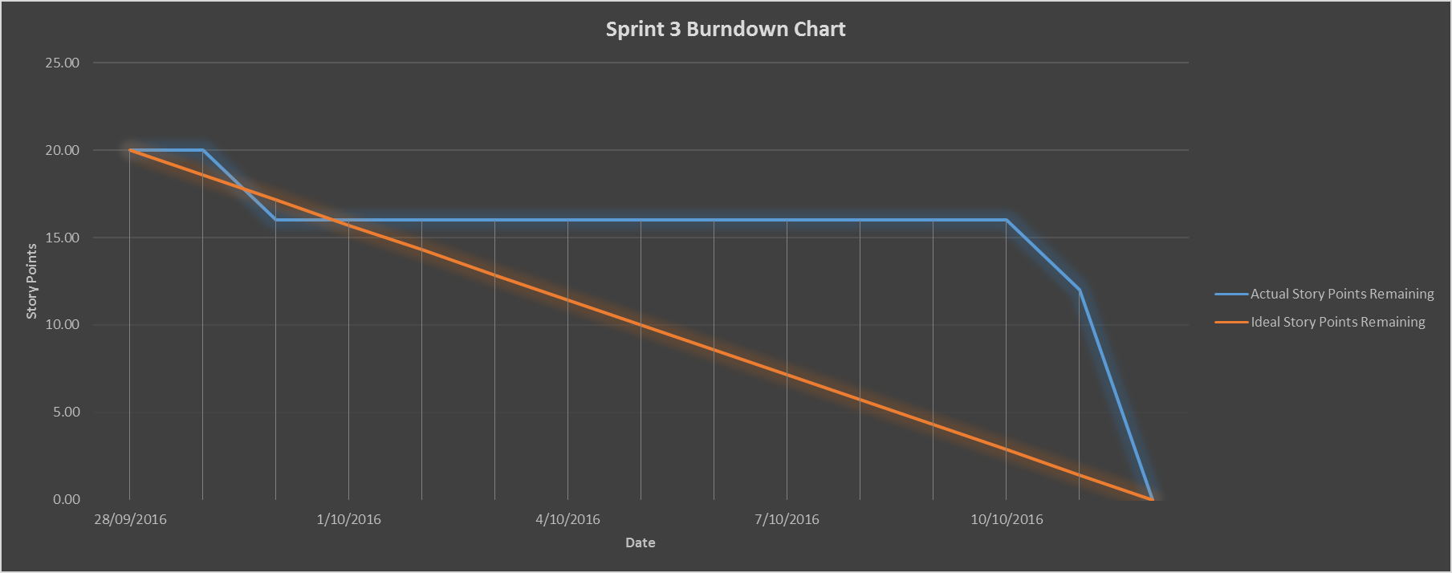

Figure 1: Sprint 3 Burndown Chart (Story Points vs. Date)